FORMAT FOR PARTICULARS OF STAFF
Name of Teacher Education Programme : Bachelor of Education (B.Ed)
(DPSE/D.EI.ED./D.EI.Ed.(ODL) /Diploma in Performing Arts/Diploma in Visual Arts/Diploma in Physical Education/Bachelor of Elementary Education (B.EI.Ed.) /B.Ed./ B.Ed.(ODL)/ B.P.Ed./ B.Ed. (Part Time) /M.Ed/M.P.Ed./B.Ed.M.Ed. (Integrated) and B.A.B.Ed. B.Sc.B.Ed. (Integrated) and Innovative Teacher Education Programme).
Sl. No. | Name Father/ Husband Name with Date of Birth | Aadhar Card No. | Self attested Photograph (front) | Whether SC/ST/ OBC/ other Category | Desig nation | Please mention the qualification relevant to the post starting from Plus 2, Graduation Post Graduation and Professional Qualification |  |  |  |  |  | Subject of Teaching | Number of Year of Teaching Experience in TEIs/ Joining date in the current assignment
 |  |  |  |  |  | %age of Marks (Plus 2) | %age of Marks (Graduation) | %age of Marks (Post Graduation) | %age of Marks (Profess ional Degree-1) | %age of Marks (Profess ional) Degree II) | NET / Ph.D (University) (Education/other subject specify) | Subject of Teaching
1 | 2 | 3 | 4 | 5 | 6 | 7 | 8 | 9 | 10 | 11 | 12 | 13 | 14
I. | Teaching Staff
1 | Dr. Narendra Narayan Walvekar D.O.B 10/10/1976 | 777419973704 | 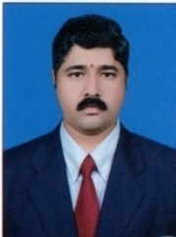  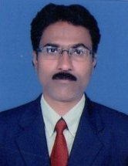 | GM | Principal | 70.06 | 58.4 | 58.5 | 77.9 | 68.90 | Ph.D in Education Dakshina Bharat Hindi Prachar Sabha Madras | Educational Philosophy & Pedagogy History | 08/01/2008 13 Years
2 | Sanjeev Manohar Naik D.O.B 25/03/1974 | 754948770458 |  | GM | Asst. Prof. | 37.33 | 64.4 | 61.2 | 71.5 | 74.4 | SLET in Education | Pedagogy Mathematics | 05/10/2007 14 Years

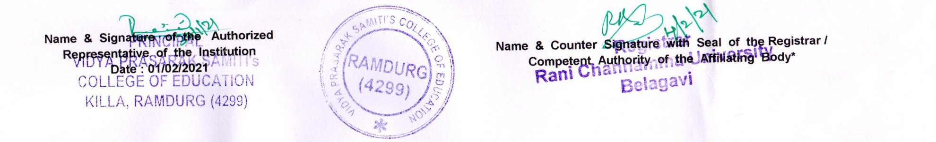
3 | Laxmappa Irappa Kalli D.O.B 20/07/1972 | 8603070408 14 | 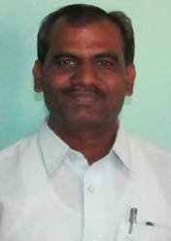  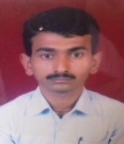 | GM | Asst. Prof. | 64.80 | 57.8 | 61.2 | 78% | 62.40 | M.Phil SLET | Perspectives in Education | 06/12/2007 14 years
4 | Maruti Rudrappa Kumbar D.O.B 15/03/1982 | 7528888365 60 |  | OBC | Asst. Prof. | 68.83 | 67.1 | 65.3 | 81.2 | 74.2 | - | Pedagogy Economics & Accountancy | 1/7/2010 11 Years
5 | Dr. Vittal Basappa Vaggar D.O.B 06/10/1981 | 4739923848 89 | 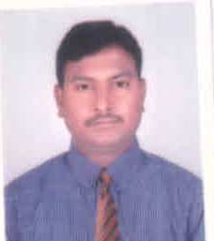 | OBC | Asst. Prof. | 57.66 | 67.47 | 62.8 | 69.6 | 66.4 | Ph.D in Education Dakshina Bharat Hindi Prachar Sabha Madras | Perspectives in Education | 11/1/2012 09 Years
6 | Giriyappa Gundappa Hubballi D.O.B 08/01/1984 | 5963902362  61 | 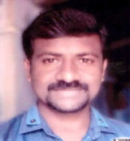 | GM | Asst. Prof. | 65.16 | 76.72 | 57.20 | 79.69 | 68.34 | - | Perspectives in Education | 16/09/2015 06 Years
7 | Mahendrakar Ashwini D.O.B 31/07/1985 | 6565973277  35 | 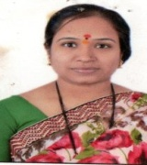 | OBC | Asst. Prof. | 73.50 | 68.12 | 59.3 | 80.7 | 73.41 | - | Pedagogy Hstory | 16/09/2015 06 Years
8 | Yallappa Siddappa Tippannavar D.O.B 15/04/1986 | 673309583759 | 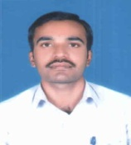 | OBC | Asst. Prof. | 70.50 | 62.5 | 62.8 | 79.84 | 71.7 | - | Pedagogy English | 2/8/2010 10 Years
9 | Smt. S. Sudha D.O.B 18/07/1966 | 842770085264 | 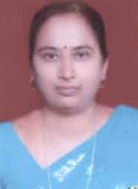 | OBC | Asst. Prof. | 51.00 | 60.1 | 58.5 | 76.4 | 59.4 | - | Pedagogy Bio-Science | 16/09/2015 06 Years
10 | Ravi S. Gadade Asst Professor D.O.B 01/06/1985 | 543328189201 | 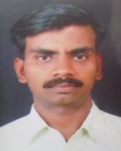 | OBC | Asst. Prof. | 72.87 | 55.02 | 56.04 | 69.09 | 59.4 | - | Pedagogy Kannada | 16/09/2015 06 Years
11 | Kiran Bankar Assst. Professor D.O.B 0/07/1981 | 400573655293 | 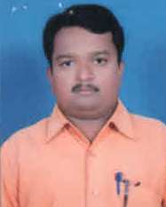 | GM | Asst. Prof. | 51.16 | 56.35 | 60 | 73 | 64.5 | - | Pedagogy Geography | 16/09/2015 06 Years
12 | Siddu Satappa Hadli D.O.B 01/01/1984 | 952859000850 | 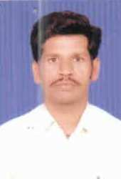 | OBC | Asst. Prof. | 77.83 | 67.70 | 61.02 | 78.7 | 63.6 | NET | Pedagogy Economics | 16/09/2015 06 Years
13 | Yallaraddi Bharmaraddi Somaraddi D.O.B 01/09/1981 | 220792052471 | 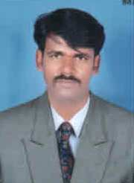 | OBC | Asst. Prof. | 68.33 | 73.64 | 62.9 | 80.79 | 73.5 | - | Perspectives in Education | 16/09/2015 06 Years
14 | Sarveshwar Manavacharya Asst. Professor. D.O.B 15/07/1985 | 544728200879 | 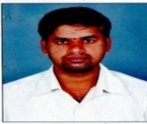 | GM | Asst. Prof. | 73.33 | 80.26 | 71.12 | - | - | - | Hindustani Music | 16/09/2015 6 Years
15 | Anand Tukkappa Lamani Phy.Edn - Ins D.O.B 26/02/1988 | 294714166269 | 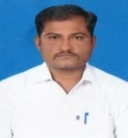 | SC | Physical Education Director | 45.5 | 70.58 | - | 80 | 70.57 | - | Physical Education & Yoga | 16/9/2015 06 Years
16 | Devendrappa Manappa Badiger D.O.B 12/07/1974 | 702484765822 | 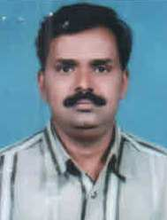 | OBC | Art Master | 63.85 | Com | 49.9 | MFA | 64.5 | - | Fine Arts | 16/09/2015 06 Years

The above appointment have been made on the basis of recommendations of the Selection Committee constituted as per the policy of the UGC / the affiliating University / Affiliating Body.

* Note: The institution shall submit the above list as per the provisions of the NCTE Regulations, 2014 indicating qualification, percentage of marks, teaching experience etc. alongwith attested copy of professional qualification & experience certificate and attested photographs of staff duly countersigned by the competent authority of the affiliating body or endorsement of the same by submitting a written approval of the competent authority of the affiliating body as per the above format.

