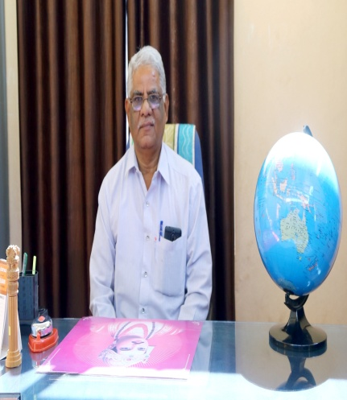 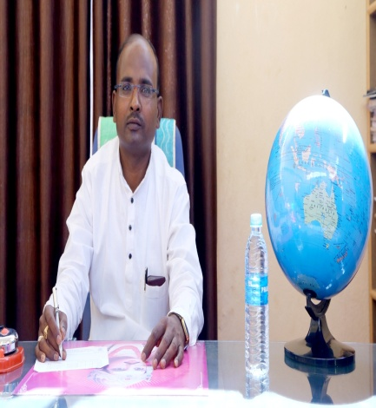 Prof. S Lepakshi Co-Ordinator Dr.R L Kullur
Retd.AssociateProfessor in Education Principal
Vidyaprasarak Samiti”sCollege Of
Education, Ramdurg

OUR COLLEGE
Our college of education, a premier institutions affiliated to Rani Chennamma University Belagavi, was started to provide professional education to youths of this region with 100 students. As time rolled down, the members of managements with great zeal and aspirations took a brave steps and started college of education in 2004. At present it is a full fledged college imparting knowledge and skills of teaching to student teachers. In the last nine years the college has made records in academic, sports and cultural fields. The College has established well equipped library and laboratories to meet the need of aspirants and has also maintained high standards in discipline. The college was affiliated to Karnataka University, Dharwad till 2009-10. From the academic year 2010-11 onwards this college is affiliated to Rani Chennamma University Belagavi, It is recognised by NCTE and Government of Karnataka. The college has successfully completed eleven years and more than 1000 trained graduates have successfully came out of this college and some of them are servicing as teachers in the different parts of the state.

FACILITIES PROVIDED
The following facilities are provided in the college
- Highly Qualified and experienced staff: The College boosts of a highly qualified and experienced staff who are dedicated and competent to meet the demands of present scenario.
- Library : A Library is a Repository of Knowledge. Our college has a fully furnished library with more than 8,000 books. We have rich collection rare books and encyclopedias. We avail students with facilities like book bank, reading rooms with reference and magazine section.
- Psychology Lab : The college has a full-fledged Psycho lab with all necessary psychological instruments and materials to facilitate psychological experiments. We have displayed the photographs of the various popular psychologists, which help our students to enrich their interest and knowledge in the field of psychology.
- Educational Technology Lab : To meet the technological advancements in the field of teaching we have established the educational technology lab with latest technological instruments like OHP, Slide projector, TV, LCD Projector, Smart Boards... etc.
- Science Lab : The science laboratory consisting of mathematical, geometrical and biological models, charts experimental materials to conduct science experiments.
- Computer Lab : Our college has the fulll fledged computer lab consisting of 32 computers, 2 printers, LAN connection, LCD projector, Broad band Internet connection facility.
- Sports and Gym Room: The sports room is equipped with necessary sports materials. We have all the facilities for indoor and outdoor games along with good and wide play ground. Our students are sharing the Gym hall along with the degree college students in the evening and the morning hours to give more importance to the health.
- Prizes and Incentives in various achievers the B.Ed course :
- Best of Bests: Special Prizes are awarded to the best achievers in different activities.
  - Best student trainee
  - Most regular student trainee
  - Best in practice teaching
  - Best Record Maintainer
  - Best Library user
  - Best Camper in CTC
  - Best teaching aid maker
  - Best Co-coordinator in educational tour
  - Best user of technology
- Special events conducted by the college
  - College organises workshop on personality development every year, which will be sponsered by Dr. Y B Kulgod President Kayaka Sanjeevani Foundation, Ramdurg.
  - College organises workshops/conferences/seminars under guidance of the school of education Rani Chennamma University, Belagavi on different curriculum.
  - College organises district level “Intercollegiate competition” on Quiz and singing.
  - Conduct the seminars by the students on curriculum and extracurricular concepts.
  - Encourage the students to participate in the social activities like Blood donation, Collecting flood relief fund, various awareness programmes.

